**Batch: D1 Roll No.: 16010122096**

**Experiment / assignment / tutorial No. 10**

**Grade: AA / AB / BB / BC / CC / CD /DD**

**Signature of the Staff In-charge with date**

Experiment No.:10

TITLE: Study of Packet Analyzer tool: Wireshark

AIM: To study and analyse various Protocols using Packet Analyzer tool: Wireshark

_____________________________________________________________________________

Expected Outcome of Experiment:

CO:

_____________________________________________________________________________

Books/ Journals/ Websites referred:

1. A. S. Tanenbaum, “Computer Networks”, Pearson Education, Fourth Edition

2. B. A. Forouzan, “Data Communications and Networking”, TMH, Fourth Edition

_____________________________________________________________________________

Pre Lab/ Prior Concepts:

IPv4 Addressing, Subnetting, Link State Protocol, Router configuration Commands

_____________________________________________________________________________

New Concepts to be learned: Packet Analyzer tool: Wireshark.

THEORY:

Wireshark is an open-source packet analyzer widely used in education, network analysis, software development, protocol development, and network troubleshooting. Often referred to as a sniffer, network protocol analyzer, or simply a network analyzer, Wireshark enables users to capture and filter packets to meet specific requirements, aiding in various networking tasks. Network security engineers use it frequently to investigate security issues. As a free tool, it captures incoming and outgoing data, often being described as a free packet-sniffing application. Wireshark operates the network card in a "promiscuous" mode, allowing it to accept and capture all incoming packets.

Uses of Wireshark

Network security engineers use it to analyze and address security issues.

It enables users to view all traffic passing through a network.

Network engineers rely on it to troubleshoot and resolve network problems.

It is helpful for diagnosing latency issues and identifying malicious activities on the network.

Wireshark can analyze and identify dropped packets.

It reveals how devices such as laptops, smartphones, desktops, switches, and routers communicate within a local network or globally.

**IMPLEMENTATION:**

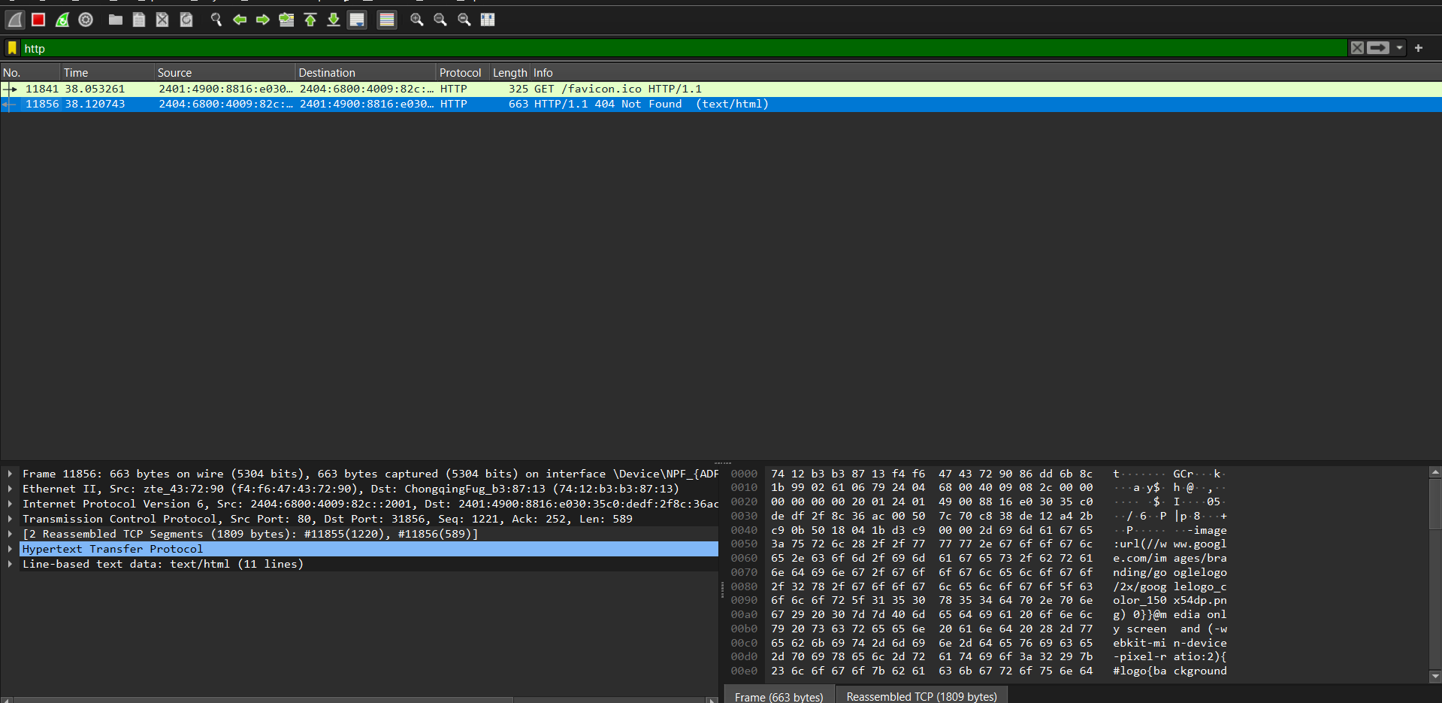

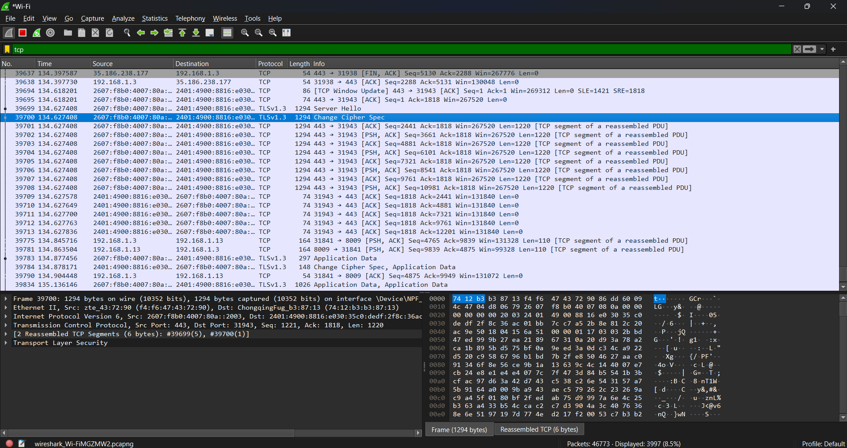

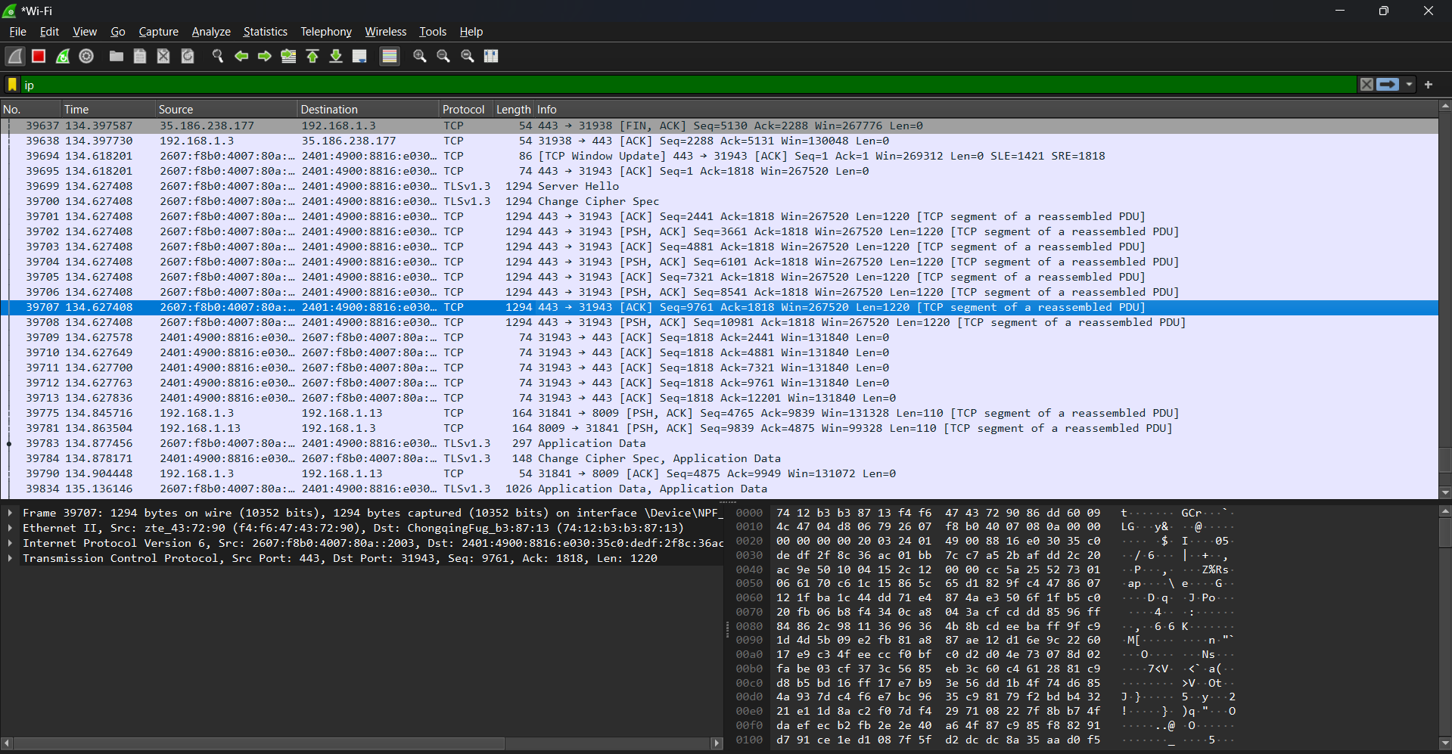

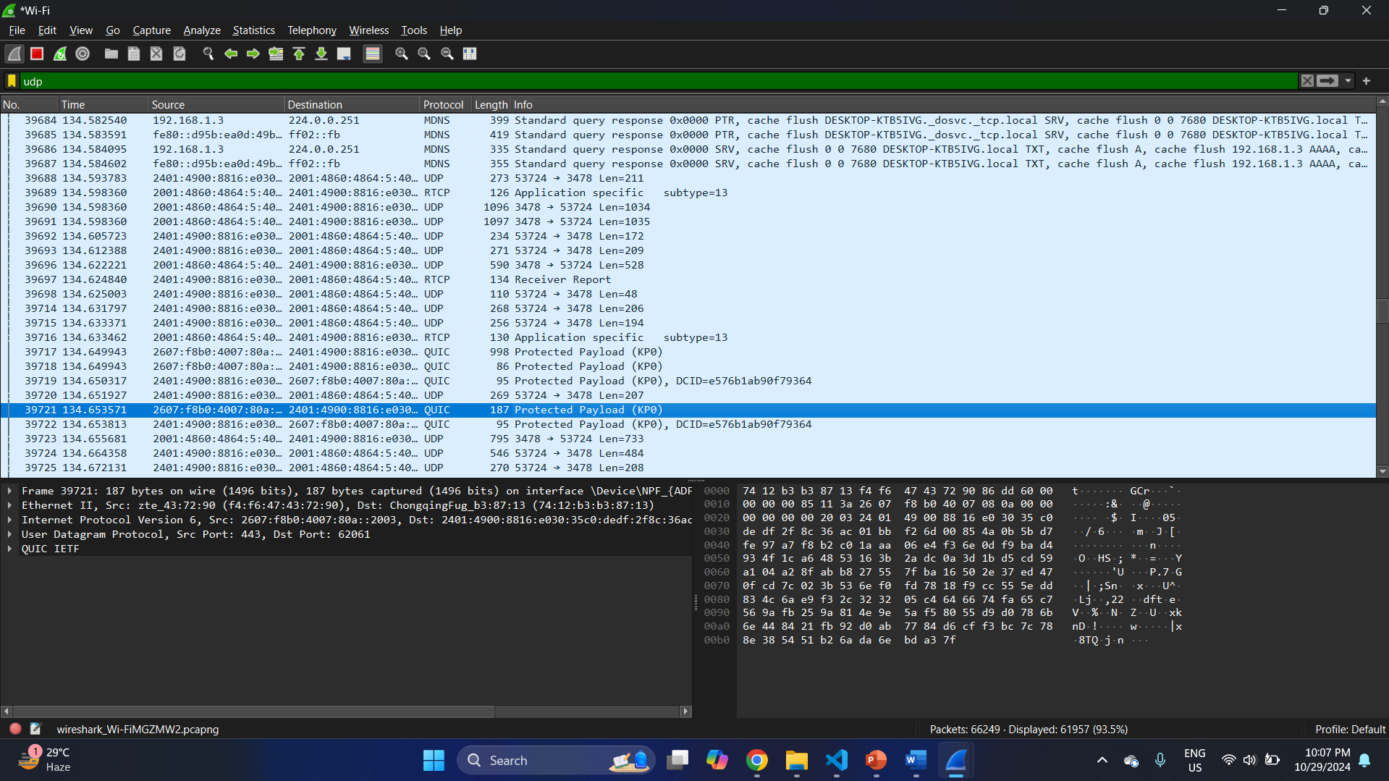

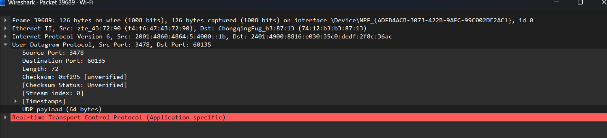

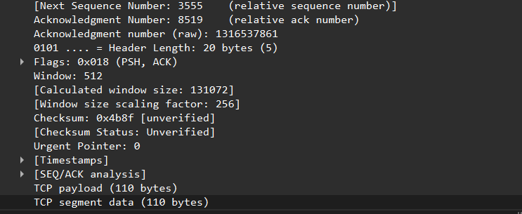

**CONCLUSION:**

Wireshark effectively captures and analyzes network protocols, providing insights into packet-level communication for troubleshooting, security, and network performance optimization.

Date: ___________ Signature of faculty in-charge